PeggleClone405 System Documentation

Evan Snook

Supervisor: Regan Mandryk

University of Saskatchewan

CMPT 405 Project implementation

April 6, 2018

Table of Contents

1 Introduction 3

1.1 Purpose 3

1.2 Scope 3

1.3 Overview 3

2 System Overview 3

3 System Architecture 3

3.1 Architectural design 3

3.2 Decomposition Description 4

3.3 Design rationale 4

4 Component Design and Purpose 5

4.1 Settings 5

4.2 Main Camera 5

4.3 Music 5

4.4 GameManager 5

4.5 LevelBlocks 5

4.6 Launcher 5

4.7 Explosion 5

4.8 Ball 5

4.9 LevelCanvas and EventSystem 5

4.10 Boundaries 5

5 Human Interface Design 6

5.1 Overview of User Interface 6

5.2 Screen Images and descriptions 6

6 Future Work 9

# Introduction

## Purpose

This software design document describes the architecture and system design of PeggleClone405.

## Scope

The goal of this project is to provide the Human-Computer Interaction lab at the University of Saskatchewan with a game that has skill based discrete rewards in which the gratuity can be scaled to observe players reactions for research purposes.

## Overview

This project is being done by Evan Snook for CMPT 405 at the University of Saskatchewan under supervision of Regan Mandryk.

# System Overview

PeggleClone405 is built using Unity3D as a fully functioning game for a personal computer.

# System Architecture

## Architectural design

The System consists of independent components that that send messages between themselves and a GameManager which manages most of the games data and information. UI and audio are primarily managed by components in the unity editor.

## Decomposition Description

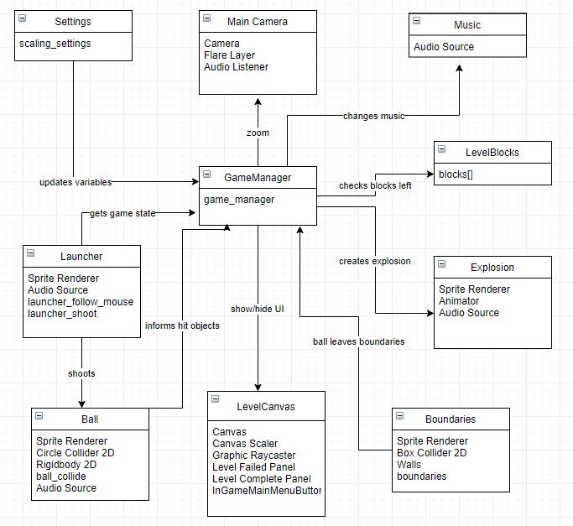

## Design rationale

Due to the nature of Unity3D, I decided that this would be the best architecture for the game as it would lower coupling to make the components very manageable. Most changes only require changing the game object and the GameManager.

# Component Design and Purpose

## Settings

Contains the script ‘scaling_setings’ which is set to not destroy on load and is used to keep track of the users preferences between scenes. These settings can be changes in the settings interface in game

## Main Camera

Default to all Unity scenes and is manipulated by the GameManager to move its position and zoom it in and out.

## Music

Contains an AudioSource to play music for the user. The GameManager changes this music when the end of the level is approaching

## GameManager

Manages all GameObjects and their interactions by sending and receiving messages when events happen and contains most relevant functions in case of said interactions.

## LevelBlocks

A container fo the block Game objects that are each a sprite and collider to detect when the ball hits them

## Launcher

Contains a script to point at where the mouse is currently located

Also contains a script to take mouse input and shoot a ball towards the mouse’s position

## Explosion

A prefab used to instantiate explosions which consists of an animation and a AudioSource

## Ball

A prefab consisting of a sprite, collider, and a rigid bod that sends messages to the game manager when it hits things.

## LevelCanvas and EventSystem

Mostly done in the unity editor and uses the scene switching scripts.

The GameManager is used to switch scenes while in game.

## Boundaries

And empty game object with a collider to detect when the ball leaves the level

Also contains some walls for the ball to bounce off of.

# Human Interface Design

## Overview of User Interface

The user loads into the main menu from which they may start a game, select a level, or modify settings. The settings will determine the win scenario for a level. Once the user loads into a level they play the level until they win or lose. They then get the option to continue to the next level, or return to the menu.

## Screen Images and descriptions

The main menu gives the player 4 option, each of which brings them to a new screen

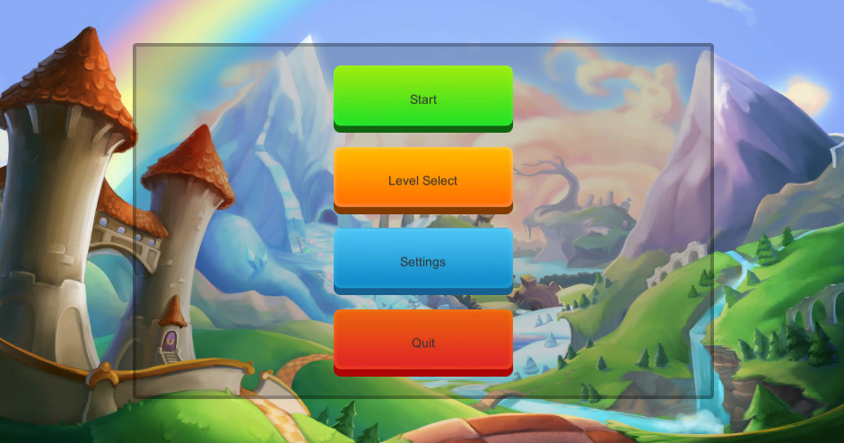

The level selector allows the player to navigate through the various levels, go back to the main menu, or start a game from a selected level.

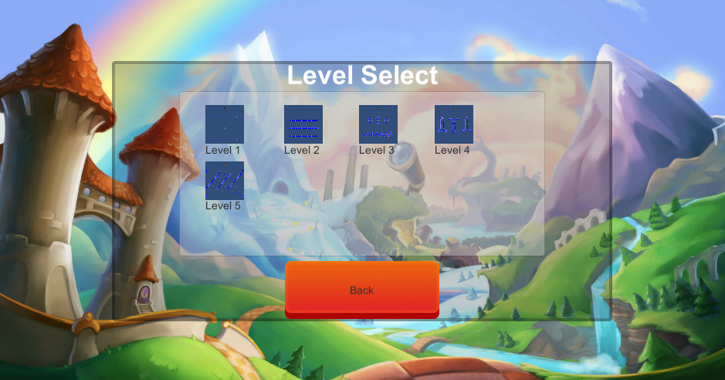

The settings screen allows the player to modify the settings for the rewards using sliders, and then return to the main menu

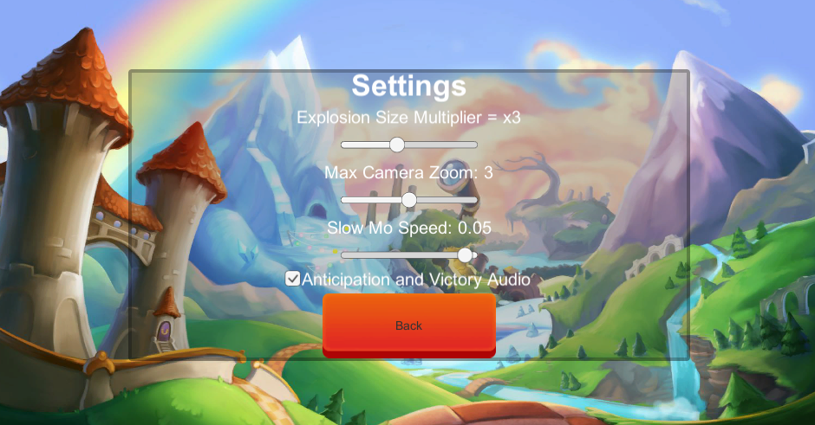

The ingame screen is where the player plays the game. They can exit to the menu at any time

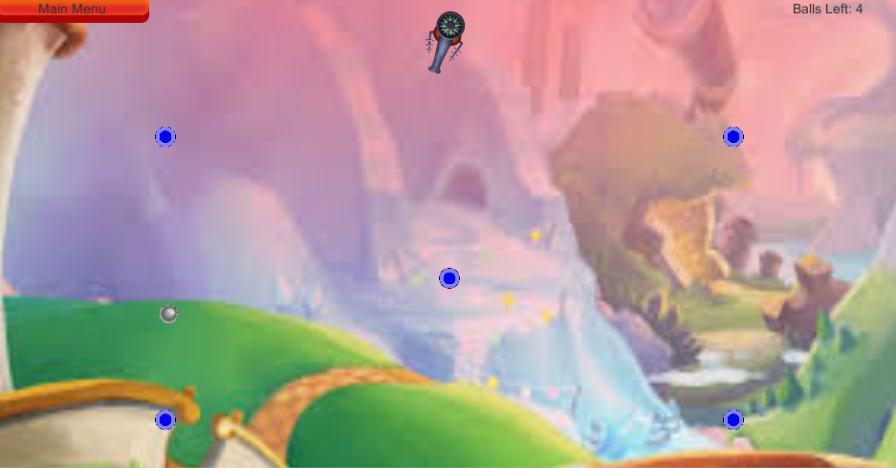

Gameover is the popup when you lose/win a game and need to chose what to do next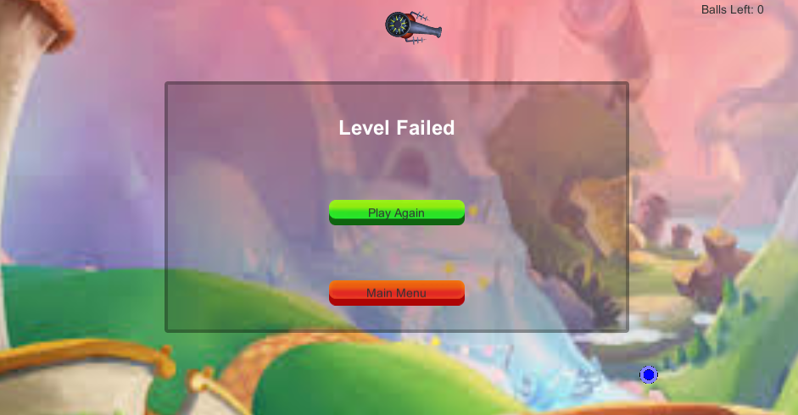

The Success popup occurs when the level is completed and you need to chose what to do next

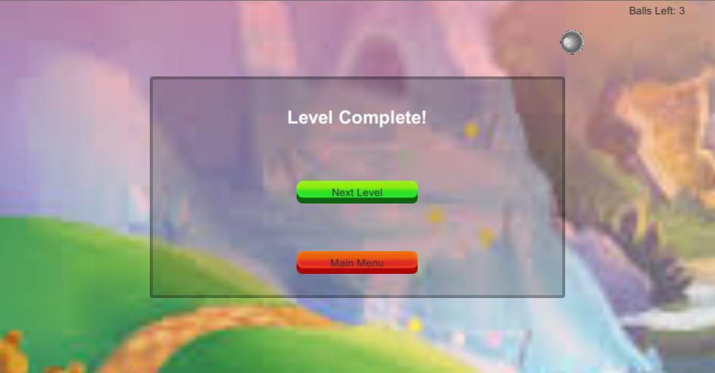

# Future Work

Thing that can be done to make the application better in the future:

* Fix current issues
* Obtain better assets for backgrounds, UI, and sprites and animations
* Add more levels
* Add indicators for the balls trajectory from the launcher before the user shoots to make it easier to play
* Add complexity to the game by incorporating in a point system and blocks that are colours other than blue that have side effects ( i.e bouncier, unbreakable, slippery)